MS2 Initial Subscriber Usability Review
Review Approach
This review follows the team's recommended feature priority order (I did change the sequence of the Virtual Tournament – it’s now last) to assess the subscriber experience. Feedback will be provided incrementally so observations can be reviewed and actioned as testing progresses.
My feedback will be in red so you can quickly scan my comments. I plan to send this feedback to you in segments so that you can quickly interpret them and take appropriate action. I will continue to build off the previous section until the document/my initial review is complete.
I will also periodically embed screenshots from my mobile phone (iPhone 16) where appropriate. My MI home is in a very rural location; I have spotty cellular service – I use Starlink to connect to my WIFI/internet service so this will be a good proxy for others that don’t have hard wired internet.

1. Authentication & Membership
- First Impressions
When I first open the app, seems a little abrupt (no initial orientation) – just a screen full of data/fields, modes, etc. Might need a quick 1-page overview to orient the user on how to use this app – there’s a lot of stuff going on.
I did a quick scan and some initial review of the Profile section, looks pretty good. Some of the data that you’re pulling is dated (About Us) – recommend you synch with the website/portal to make it’s recent (e.g., it only shows Kevin and I – no mention of Bill McGuire).
I quickly switched from Full Library Mode to Field Mode. I like the color palette that was used for the two different modes – very distinctive and should help with the different lighting conditions. Also, like the larger text and formatting in Field Mode. Nice job.
The keyboard locking is excellent, and I like the two different options. Passive – you can let the system automatically do it – this should probably be user determined on the length of time (e.g., 20 seconds, 60 seconds, etc.). I’m not a fan of how quickly it’s doing it right now. I also really like the Active – I can physically do it on my own. Having both options is great.
- Subscriber Experience
No problems logging in, I did that yesterday and just continued on. I’m still not 100% certain where I’m at (in Field mode or Full Library mode) – the header says “Full Library mode” but the mode selector button “Field Mode” is in Orange. Seems inconsistent to me – shouldn’t Full Library Mode be highlighted in Orange if that’s where I’m at?
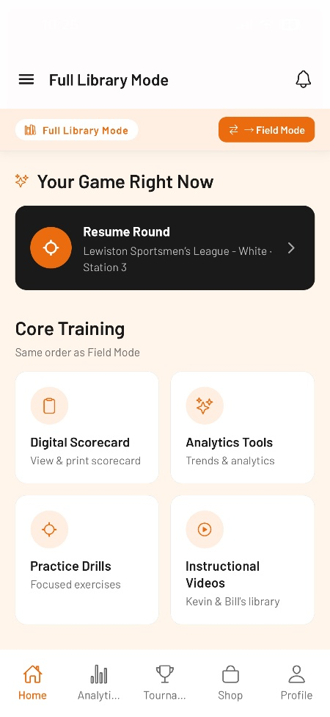
My phone keeps going into conserve mode (shuts down the display after 20-30 seconds) which is awkward – don’t know if it’s my phone or the app that’s doing this which one of the things that we might want to make sure we address so the user knows what to change if they get irritated.
I don’t think we should include the Community button in this section (Profile) – not really what’s intended for, more like specific sporting clays issues/thoughts. Probably deserves space like the other services (analytics, virtual tournament, instructional videos, etc.).
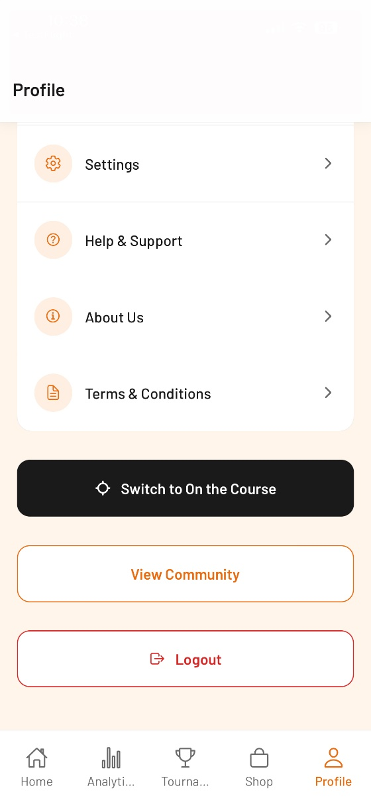
- Key Issues
- Why Switch to On the Course vs. Field Mode – seems confusing at the bottom of Full Library Mode Profile? Am I missing something?
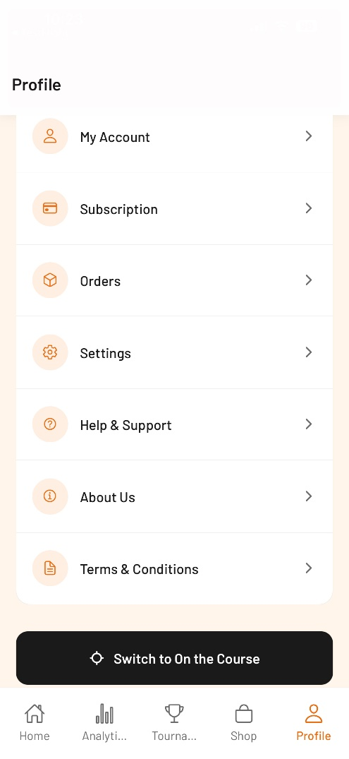
- Help and Support – although I would like to say 24-48 hours for a reply, it’s simply not true. Most problems occur during the weekend, let’s say on Saturday morning – by the time it goes from the user to me (support@claymaster.net) and then I triage it and forward it on to Ruben it’s now Saturday afternoon – Ruben doesn’t look at until when he comes in on Monday afternoon and depending on his workflow. He might not get to it until Tuesday afternoon (it’s now 3 days and we haven’t replied back to the user with a recommended solution). Let’s remove the timing for now until we can better establish a real service level commitment which we don’t have right now.
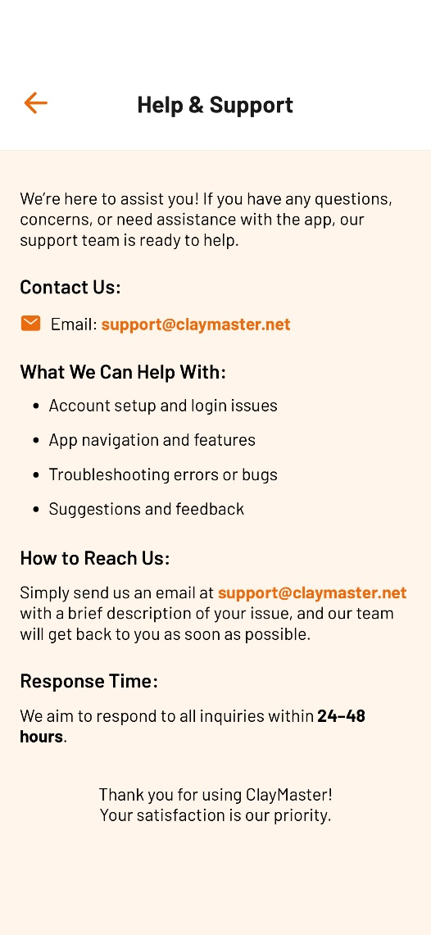
- How are notifications sent to the user? The little bell on top – I like the idea of it but how do we (ClayMaster) do this.
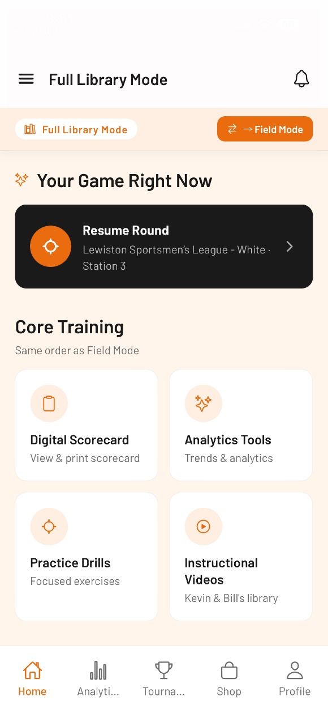

2. Field Mode – Digital Scorecard
- First Impressions
I like the overall format and structure, looks good/intuitive and definitely follows the design guidelines we initially established. Nice job! Good use of spacing and I like the larger buttons. I went through it all and have some recommendations.
This is one of the core capabilities – so we need to get this right the first time.
I think this is a big improvement over MS1 from a user ease of use standpoint and keeping to something they will actively use.
- Subscriber Experience
I think this is very positive. Much easier to see and operate (minimal fat finger errors I think). Also intuitive for the user, only a couple of real decision points – most things are explained well to minimize questions/understanding issues.
- Key Issues
Some recommended changes (see below).
- Opportunities for Improvement
- Change sequence direction for Squad Size – I like 1–6 better than 6-1. This is how shooters think.
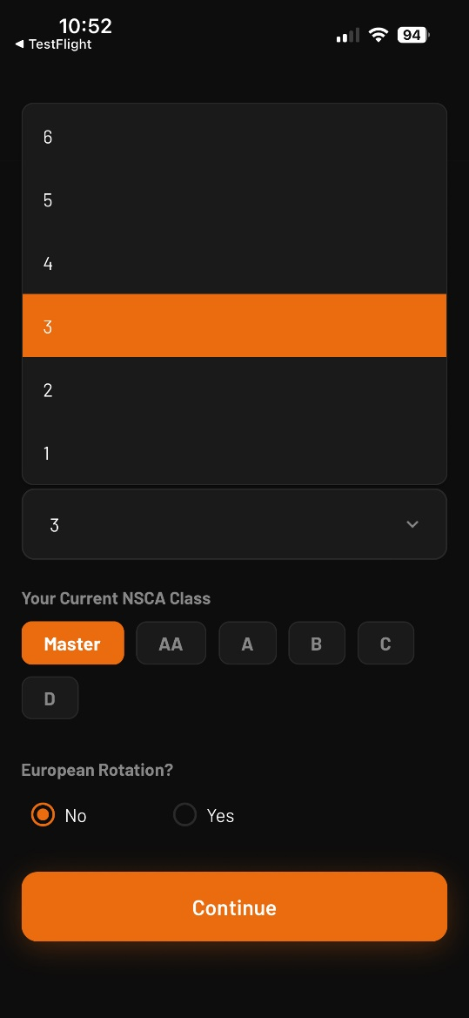
- Change the color the miss and/or the hit – they (orange and red) look too similar on the total line, more differentiation maybe like you do on the score total with green and red. I like that we use both a symbol and color for each button (to help color blind shooters).
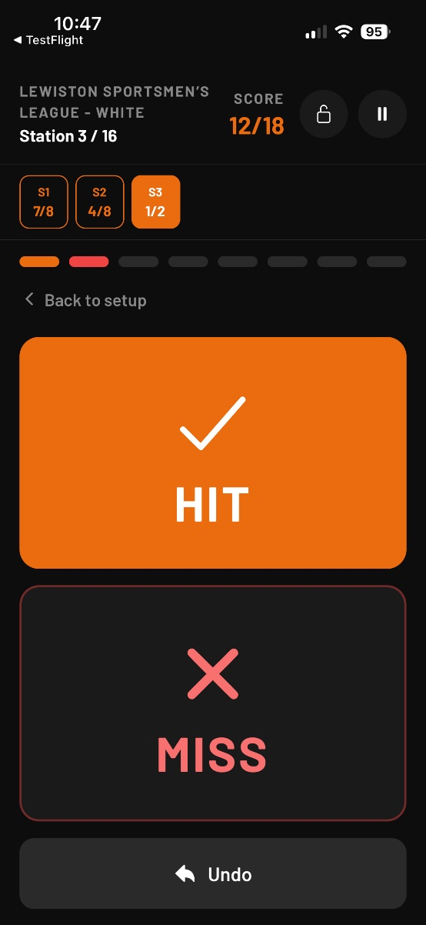
- Subtotal counts of Stations and Score – these should reflect the total of the station (e.g., we know from the initial configuration of the station how many report or true pairs of total target there will be. Use that total number as the denominator in the station total – 1/8 in the Orange display field vs. 1/2.
Change the way the Station progress is shown – I think Station 3/16 is too close to how we’re shooting the subtotal counts – use something like Station 3 of 16 instead. Much better.
If I look at the current score, it shows 12/18 – you’re updating the numerator and denominator at the same time which is kind of cool, but I think we need to modify the title to reflect that – maybe Current Score to indicate it’s being updated every time you enter a hit or miss.
- Percent Accuracy is redundant – not needed. Delete it. It’s the same as the score 79/100. So, kill the 79% Accuracy. I like the colors on this very good.
Why not include the targets next to each Station as a quick visual reminder – we have room/space for it? (e.g., Station 1 – TP Crosser/Crosser, Station 2 – RP Quartering/Rabbue, etc.) this will really help the shooter recall the station.
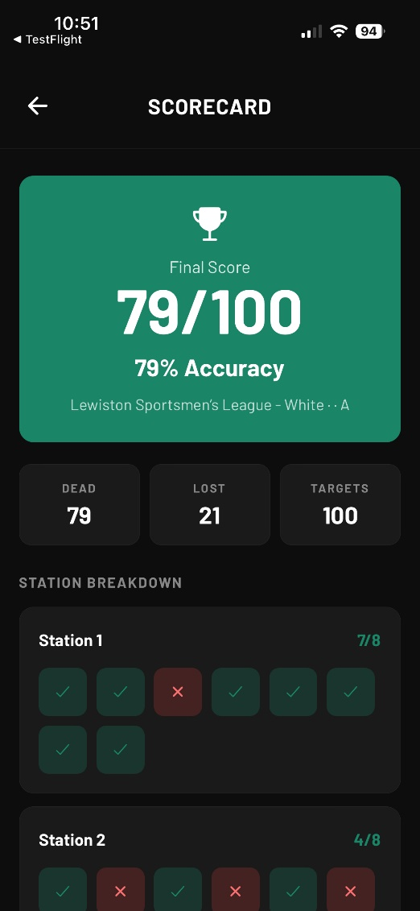
- We need to reword this description (Submit this round to the server? Local draft will be cleared.), translate to appropriate shooter language so they clearly understand it. Maybe “Save this round (it will be available for Analytics and other uses)? Or something like that.
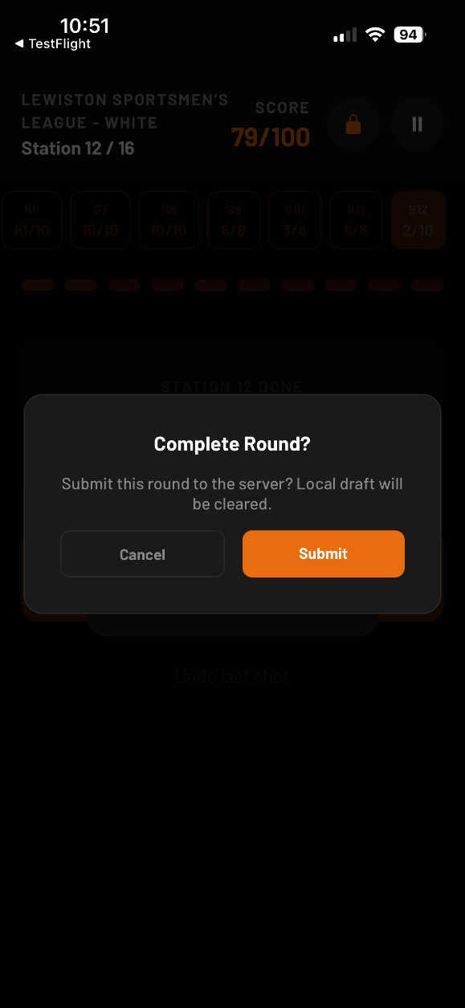

3. Training Library
- First Impressions
I started in Field Mode first with Instructional Videos. It just says “Videos” on the bottom which might be ok (you do break them down once you click on it) but could be confusing to the subscriber.
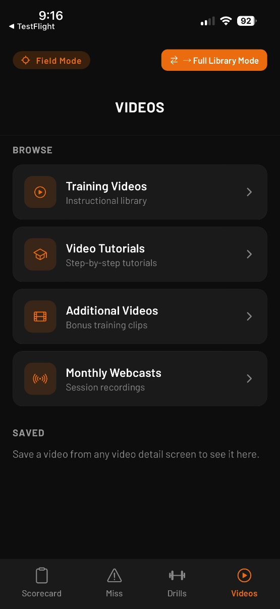
I think the format is actually pretty good – everything fits within the format, easy to see and it’s all structured. I don’t know if this the best way though – the current sequence is confusing (Training Videos, Video Tutorials, Additional Videos, Monthly Webcasts). First thing – remove Monthly Webcasts from Field Mode. They are way too long (>45 mins) and should only be in Full Library. I think the same thing with the Video Tutorials – these are all set up for the Analytics which I don’t think someone will do in Field Mode – I would also move this to Full Library. I think the first guiding principle should be only include things that can help someone when they in the Field (on the course). Second one is make it very easy for the user to find the information.
I wonder if this is better with some kind of keywords and a basic search filter screen first. Maybe something like the 12 target presentations (almost the same as you use when selecting for Traps in the digital scorecard). If the user selects Quartering all the videos that match quartering come up. This might be too difficult/time consuming to include right now.
- Subscriber Experience
The primary thing the subscribers want is easy to use and performance (no lag or buffering), when they press play, they see a HD video play with no issues. Right now, we have close to 60 videos within ClayMaster with an average of 5-7 videos being added each month. So, this is job #1 for the videos
- Key Issues
Video performance is the key issue followed closely by being able to quickly retrieve the right video that the subscriber wants to see to help them during their practice session.
- Opportunities for Improvement
  - Instructional Videos
    - I don’t like the 2nd screen under training videos – would be better with the thumbnails than all the text, very boring and unnecessary
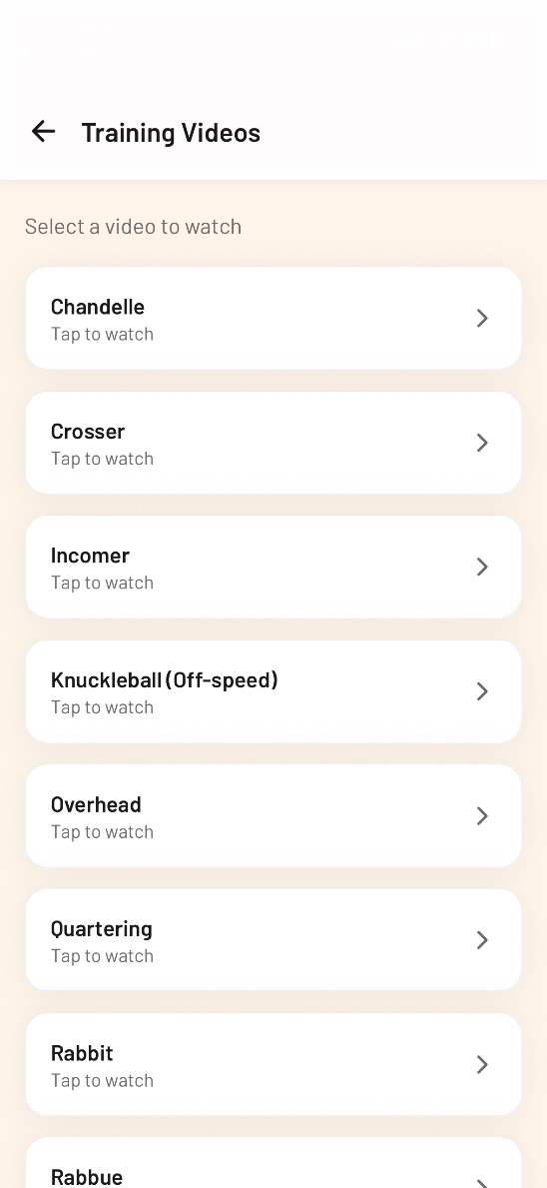
    - Change Training Videos to Instructional Videos – all of the videos are training videos, doesn’t make sense
    - There are two different kinds of Instructional Videos: 1. Target Presentations and 2. ClayMaster Vision detailed video for a total of 24 + 1 on Tournament Preparation (Pro Subscribers). They need to be included under Instructional Videos
    - Performance is awful – I won’t allow this to go forward like this. Too much buffering, I can’t even watch 5 seconds of the Chandelle video with a stoppage
    - I like the idea of saving the video to watch it in Field Mode – I didn’t test it but like this idea
    - Missing sub-categories in the additional videos like what’s in the portal – too much without some more organization. This helps the user find what they need
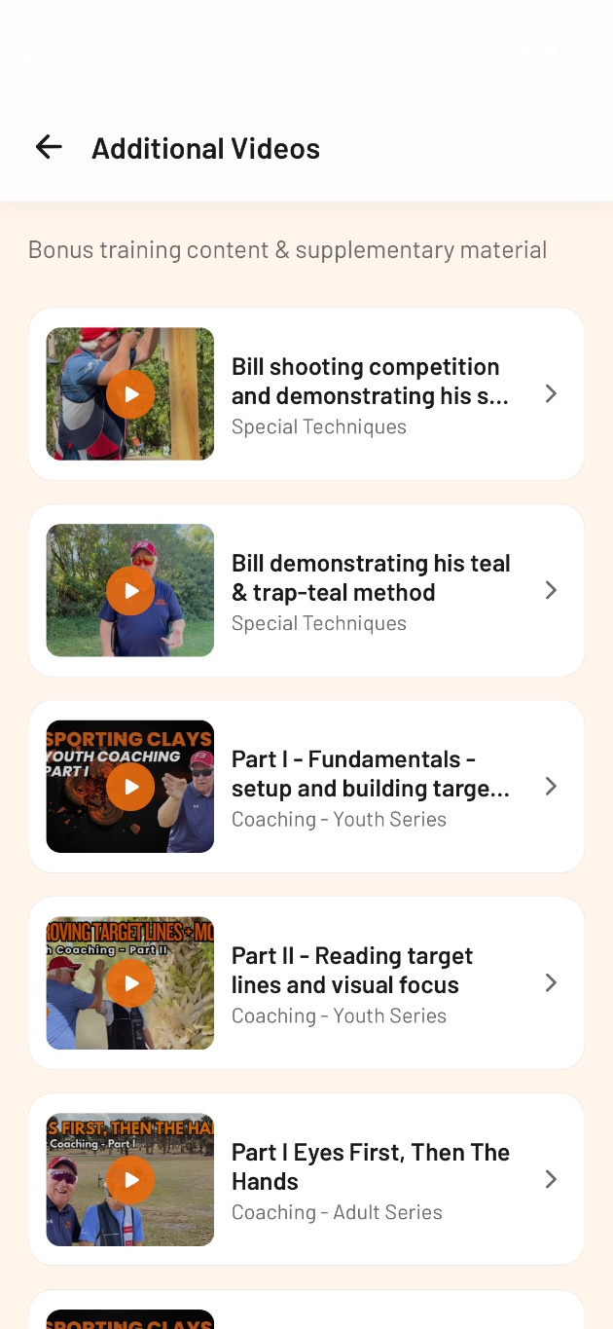
    - Needs to use something for the sub-categories like we use in the portal
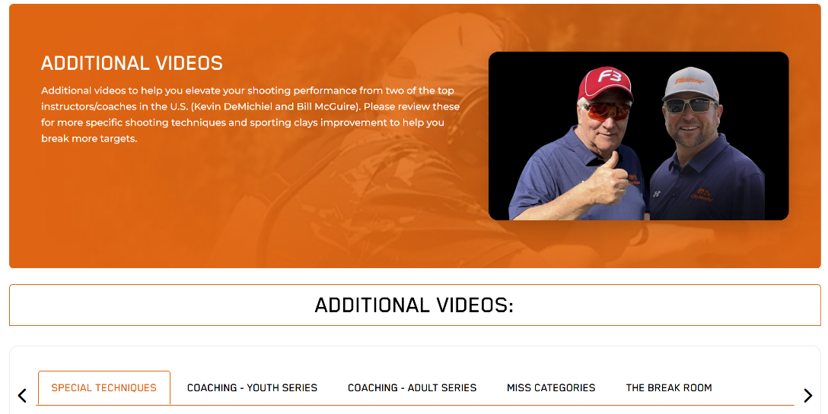
  - Practice Drills
    - Remember, the practice drills have drills for Classic subscribers (9) and drills for Pro Subscribers (all 13). Need to make sure this works properly (the test log in I’m using is for Pro – so I can see all 13 which is good, but I don’t know about Classic)
    - The performance and format are good – speed was fine (I used the View on all 13 drills) and also very readable
    - Can we show a thumbnail to make it more visual or too hard?
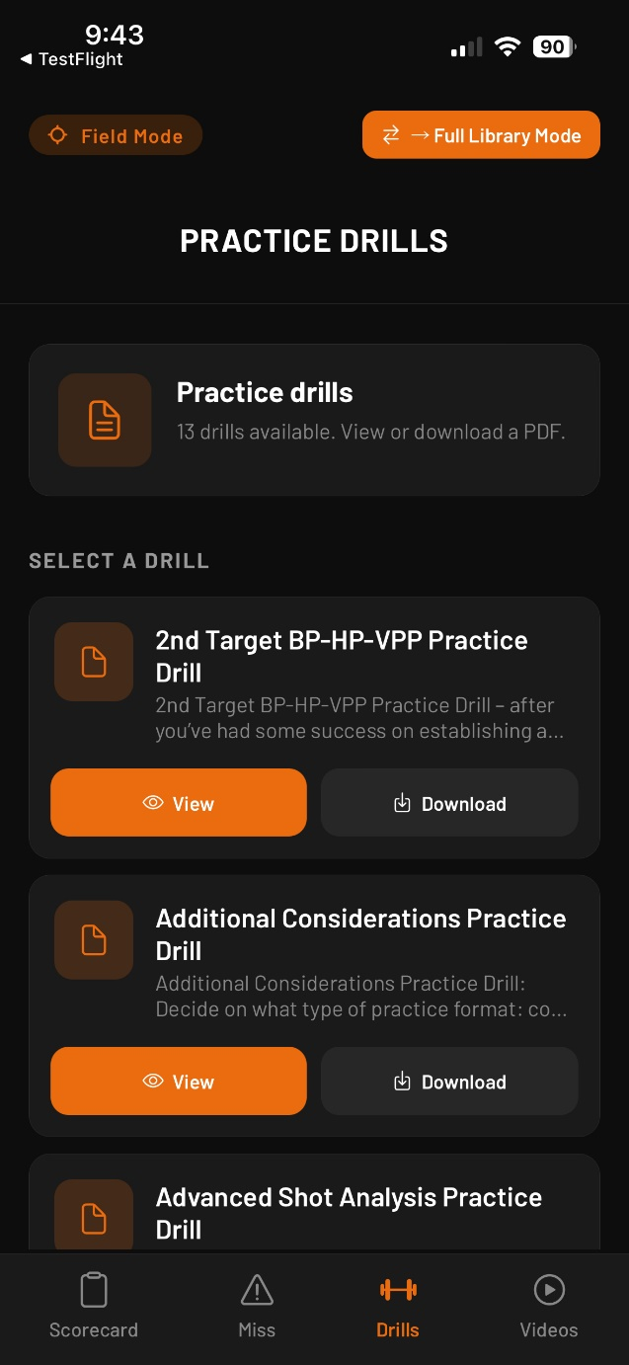
  - Documents & Resources
    - I think this is Additional Documents (?) – which isn’t currently in Field Mode. This might be a problem; we have some of the Miss Performance Packs (presentations) coming soon and need to figure out where we will be storing these on the portal. We might need to include within Additional Documents or create a new folder to store both the Miss Diagnostic, the Miss Profile, the Miss Performance Packs, and the Miss Videos. Right now, I’m inclined to store them all together under one topic Miss Categories. But this is still open right now.
    - I did a quick preview of the Full Library mode and found the Documents – kind of confusing, I had to go the Menu to find it vs. on the screen under Core Training or Portal. This isn’t intuitive and would be confusing for the user. I think these need to match or at a minimum show the major topics (Documents) on the screen (Core Training or Portal).
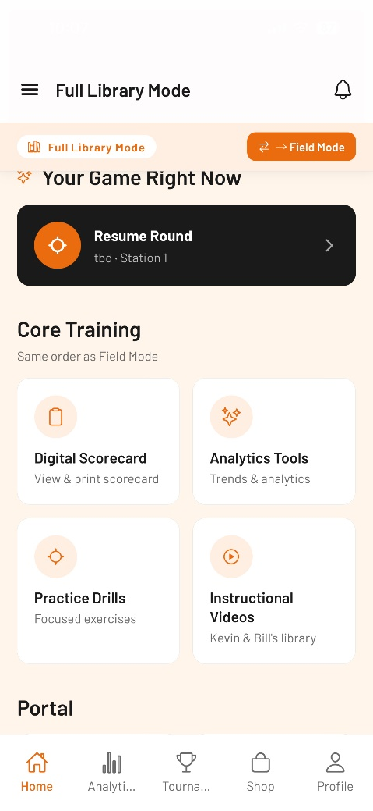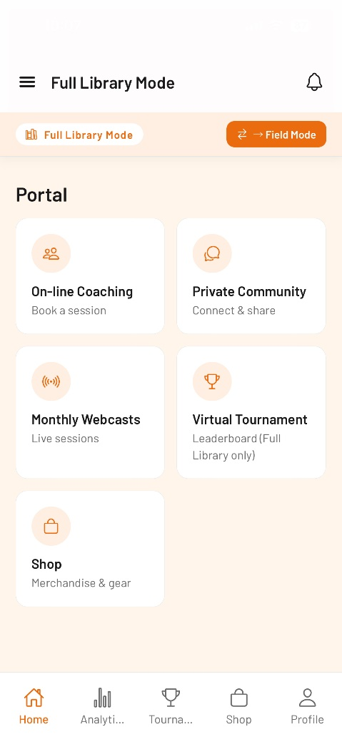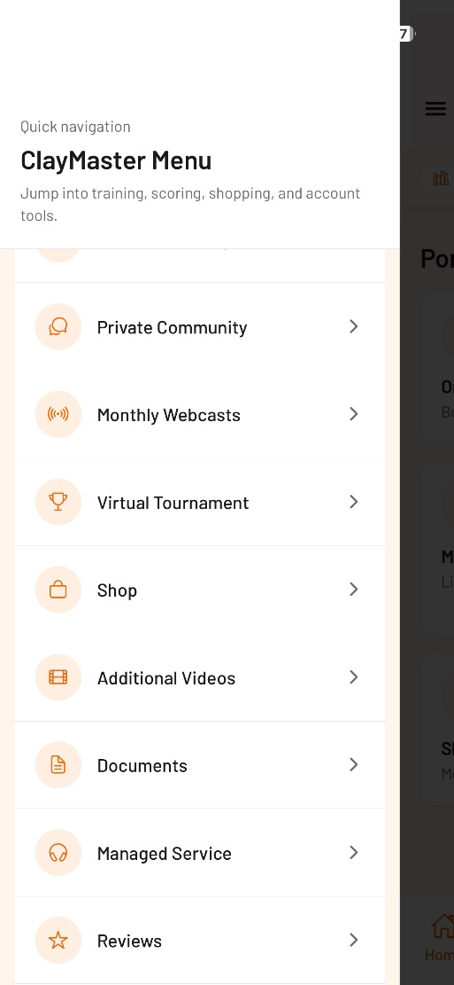

4. Online Coaching & Managed Services
- First Impressions
On-line Coaching:
Looked at this section within the Full Library Mode. Kind of confusing – I see Core Training and Portal (I think we need to think through this – of course, it’s broader than just On-line Coaching and Managed Services. I think it’s confusing because many of the services like on-line coaching, analytics, etc. are Core Training. It might be better to just have one topic or figure out a better way to split these). Not working for me as currently presented.
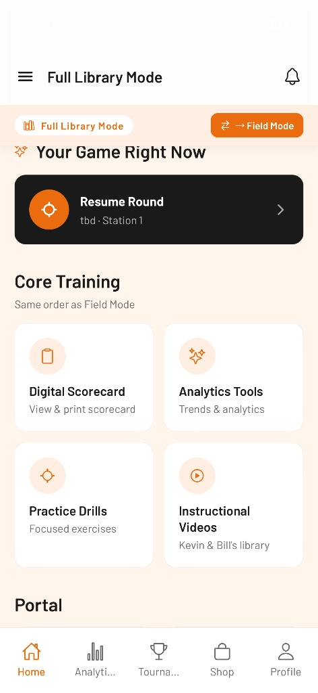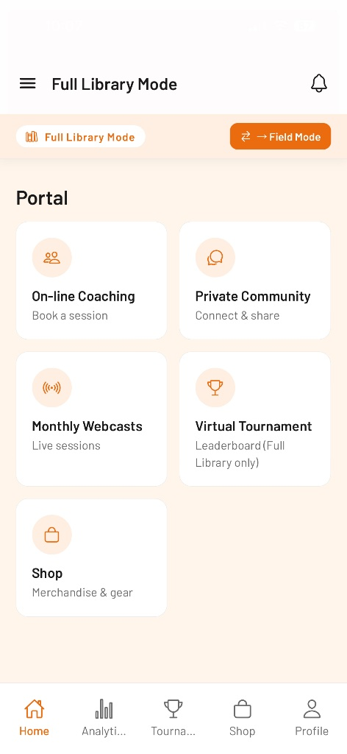
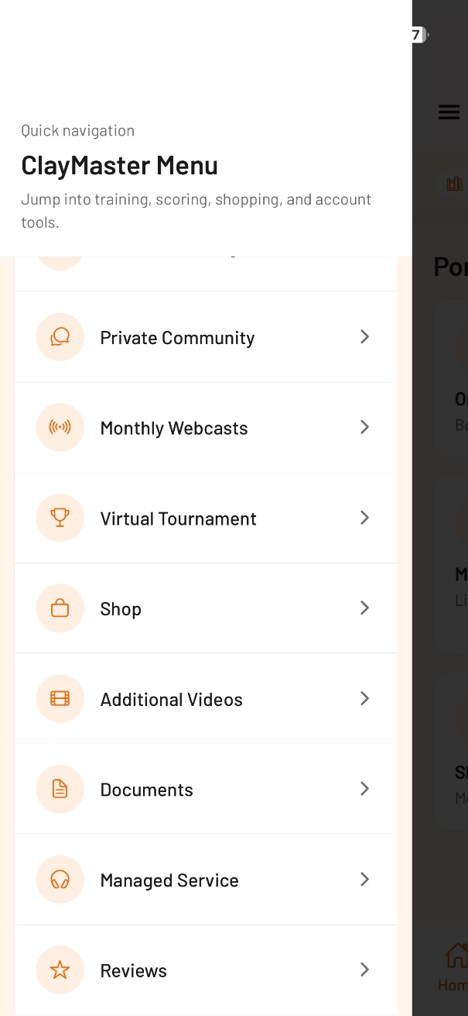
Now, back to On-line Coaching. I just pressed the Book Session (took ~15-20 seconds to initialize, not sure why?) I think it should be focused on booking session vs. trying to sell more sessions. Can’t we use some type of monitor to show the buy sessions (<if less than 3 left), show the buy more sessions otherwise just have a button press (Purchase more coaching sessions?).
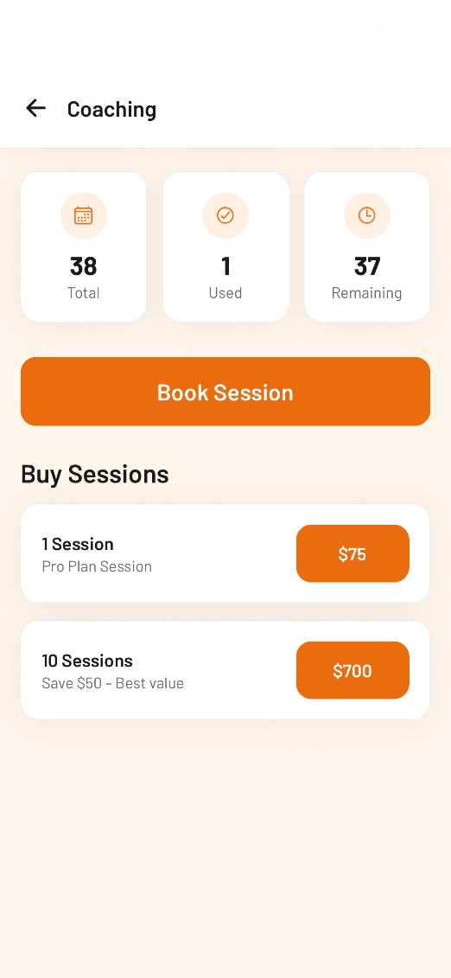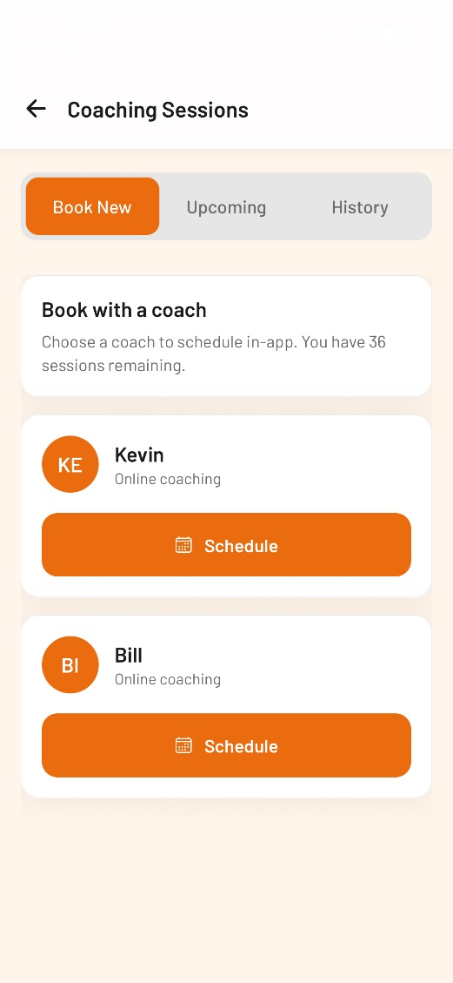
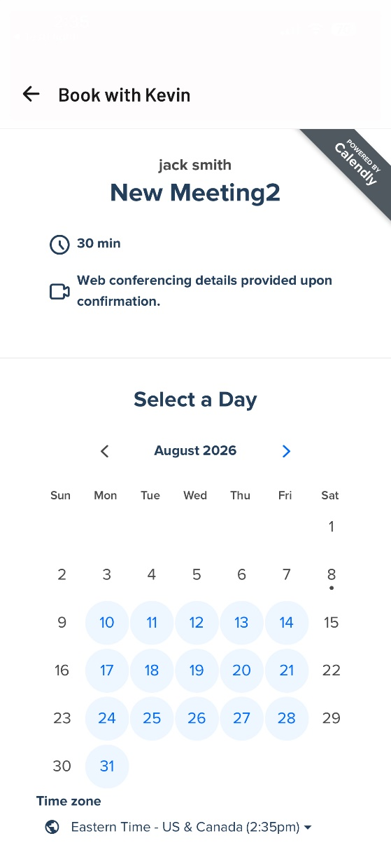
Let’s stay consistent – I’ve use On-line Coaching on the website/portal – please stay with this format (On-line). I booked a session with Kevin on August 14th at 9am but I don’t see it on my upcoming sessions yet. Very important to have visibility to these – this needs to be rock solid. It also didn’t decrement my session counter still at 36 – maybe it’s still confirming?
Pretty straightforward other than my previous comments.

Managed Services:
Ok, another confusing initial orientation – nowhere on the initial Full Library mode screen (under Core Training or Portal) does it shows Managed Services instead I had to go to the ClayMaster Menu Screen in upper left corner and there I could find Managed Services. We need to make this much more clear to our users. I like consistency, let’s make it super easy/simple for people to navigate to all of the various sections/folders.
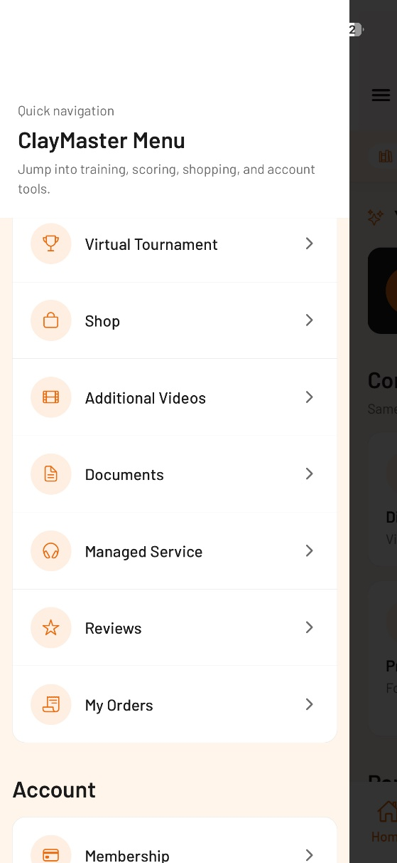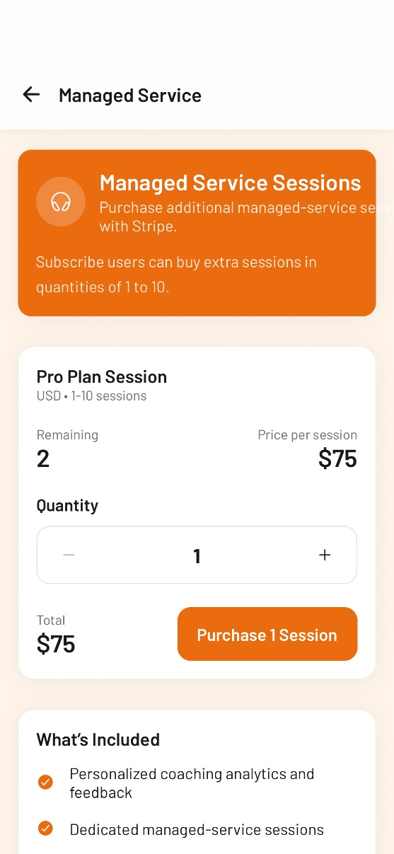
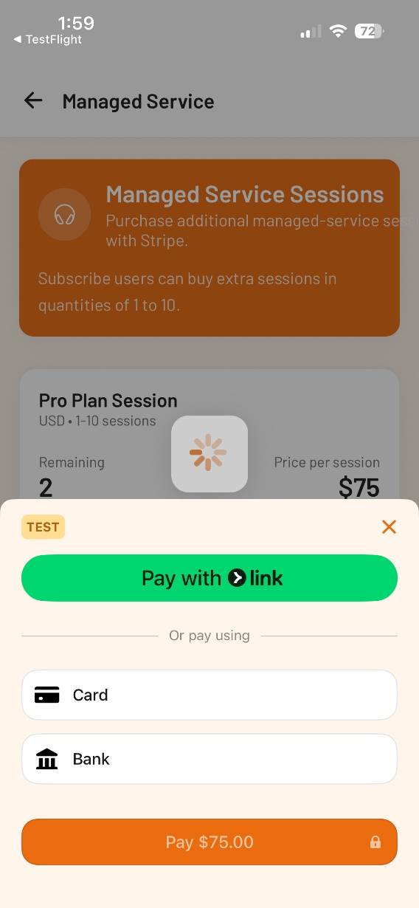
Once I navigated to the Managed Service screen – really nothing that tells me what it is (I, obviously, know what it is, but not a new user). I think all of these (initial screens would benefit from 1 – 3 sentence brief description like we have in the portal). The only managed service that we provide at the present time is for analytics (basically we will take the users scorecard and conduct a full analytics report for them - ~14 page report and send it back to them).

I don’t think this is working, it only lets me purchase additional sessions. No button to select to confirm that I want to have Managed Services – Analytics to be performed for me. It also requires a copy of the my latest digital scorecard to be best to ClayMaster. This needs work.

- Subscriber Experience
On-line Coaching: Pretty close, needs some refinements but looks like the structure is in place (see my comments above).
Managed Services – Analytics: This needs a lot of work – missing the whole confirmation and details on what it does and initial action step to make it happen.
- Key Issues
See above for both areas.
- Opportunities for Improvement
See above for both areas.

5. Private Community
- First Impressions
Accessed it via Full Library Model – Portal section which is fine and straightforward. Not sure about the sequence in the Portal section (doesn’t seem to be any specific order, when in doubt alphabetic seems to be logical – take a look at this).
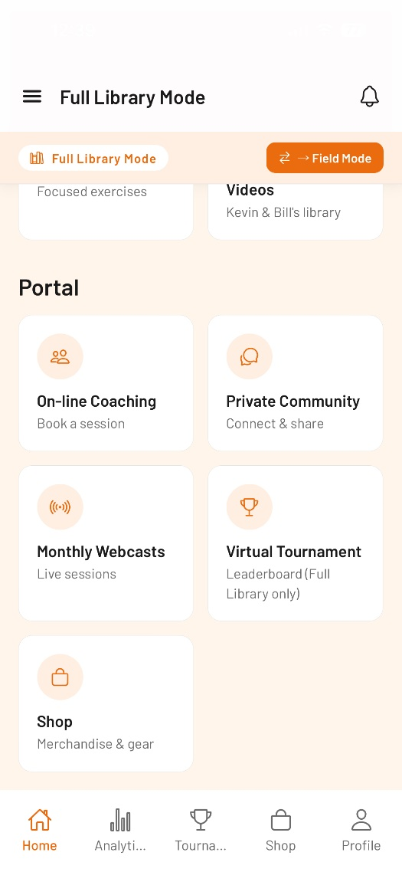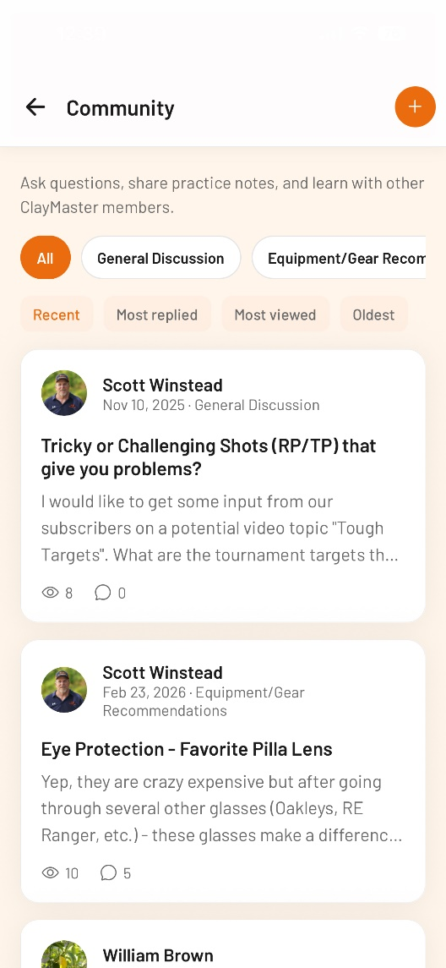
Played around looking at various posts and most viewed, most recent, etc. seemed to work fine.
Tried to create a new post – didn’t work for me, no messages, not just kind of stood still and no response. Exited came back in and the post I was working on disappeared. It might just be the test environment and my test ID (mark bravo).
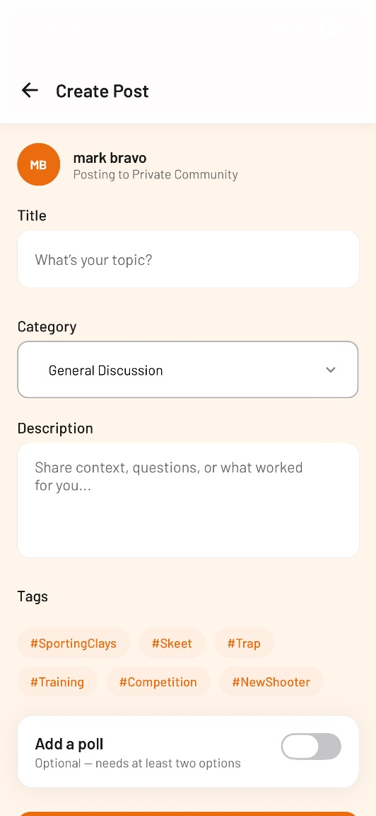
- Subscriber Experience
See above.
- Key Issues
Couldn’t create a new post – might have been related to test access or my test user ID
- Opportunities for Improvement

6. Virtual Tournament
- First Impressions
Just like Private Community Forum, accessed via Full Library Mode within the Portal section which is fine/appropriate. Again, check the intentional sequence of the items – I would make it alphabetic or something appropriate for these items.
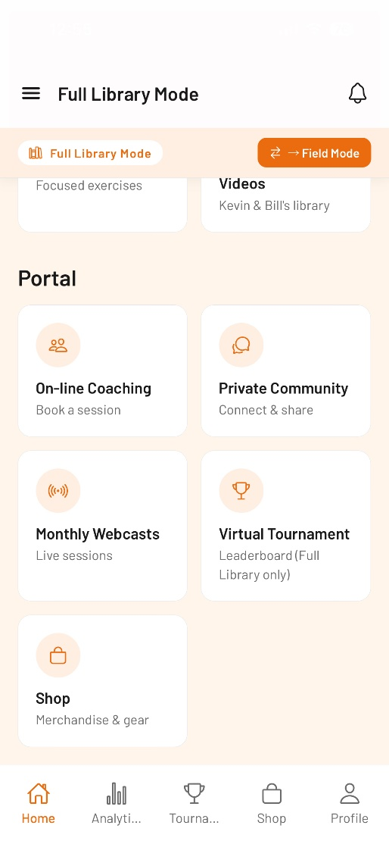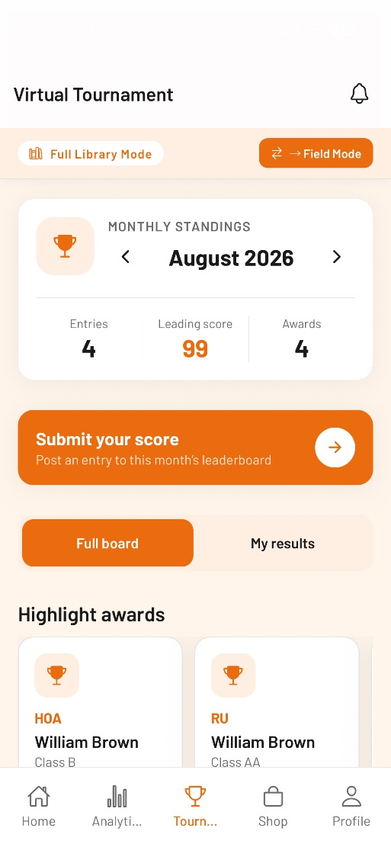
On the Leaderboard screen everything seemed to be ok, good display, good format. Got a little confused on why Field Mode option? Why is this here if it’s not related to Field Mode – is this a shortcut for the user? Seems odd.

Also, I’m not sure about the bottom footer. Virtual Tournament is not a popular option right now, more of a novelty – why put this as an icon in the footer vs. other things that are more popular with our current subscribers. Or better yet, the make the footer customizable – the user can customize to fit their needs?
- Subscriber Experience
No issues – everything worked fine, format is good. Take a look at couple of my questions above.
- Key Issues
No major issues.
- Opportunities for Improvement
See above.

Overall Assessment
- Biggest strengths
In general, the readability and format were good. I could see some of the items better on the mobile screens than my laptop, which is good. The Full Library and Field modes will be very useful as more people use ClayMaster in the different settings. It’s great that we took the steps to make it easier for them (customer experience).
- Biggest usability concerns
Some inconsistencies that need to be ironed out – haven’t seen the Analytics yet, one of my key concerns and video performance was terrible. Both of these are major concerns of mine.
- Top priorities before the next milestone

